Original article:
Hemangioma of Tongue with Phlebolith: A Rare presentation
¹ Dr. Jigna S Shah (MDS)¹, ² Dr. Vijay K Asrani²

¹ Professor and Head, ² Post Graduate Student
Department of Oral Medicine and Radiology,
Government Dental College and Hospital, Ahmedabad
Corresponding Author: Name: Dr. Vijay K Asrani

Abstract:
Hemangioma is considered a tumor of dilated blood vessels which is usually present since birth and involute over time. Though common in head and neck region, oral cavity is seldom affected by hemangiomas. When hemangioma involves the tongue, besides esthetic hassle it causes difficulty in mastication and swallowing. To avoid complication an early diagnosis and appropriate treatment is required. This paper reports a case of hemangioma of tongue with phlebolith over right lateral border of tongue in a 59 year old female patient focusing on roles of Plain radiographs, Color Doppler and CT scan in diagnosing and in deciding appropriate treatment of hemangioma.
Keywords: Color Doppler, hemangioma, phlebolith

Introduction:
As per the classification given by Mulliken and Glovacki in 1982, vascular deformities are divided into 2 main groups: hemangiomas and vascular malformations.
Hemangioma is a common vascular tumor affecting head and neck region. However, they are rare in the oral cavity but may occur on tongue, lips, buccal mucosa, gingiva, palatal mucosa, salivary glands, alveolar ridge, and jaw bones.Females appear to have a slightly higher incidence than males. ^{1, 2}
It usually manifest as swelling with bluish hue and may be associated with phlebolith. Very few cases have been reported regarding its occurrence in the oral cavity. It can be diagnosed on the basis on clinical examination & soft tissue radiographs/ Color Doppler ultrasonography/ Computed tomography (CT) scan /Magnetic Resonance Imaging (MRI).¹
Clinically hemangioma appears as soft mass, smooth or lobulated, and may vary in size from a few millimeters to several centimeters. They are usually deep red and may blanch on the application of pressure (positive diascopy).^{2, 3}
Usually hemangioma resolves in most of the cases, however for persistent lesions various treatment options are available which include, laser therapy, cryotherapy, surgical excision. Out of this sclerotherapy is gaining an advantage because of its efficacy, ease of use, minimal complications as compared to surgery and other treatment modalities.
After an extensive search of the English language literature, only 23 cases of head & neck hemangiomas with phleboliths were properly documented. Seven cases have been reported in buccal mucosa or cheek, ten cases were in the parotid, submandibular glands and submental, onecase was in the floor of the mouth,one case was in the hypopharynx, three cases were on masseterand one case was in the para-pharyngealspace.⁴
Here a case is presented of hemangioma with phlebolith in a female patient having complain of swelling over right lateral border of tongue since 5 month.
Case report
A female patient aged 59 years reported to the Oral Medicine department of Government Dental College and Hospital, Ahmedabad, Gujarat, with the chief complain of swelling over the right lateral border of tongue since 5 months and it was asymptomatic. The patient gives history of trauma by her teeth at the same sight before 6 months. The patient did not have systemic disease and on physical examination, she appeared to be healthy. The rest of the general physical examinations were within normal limits.
Oral examination revealed a single well defined pinkish dome shaped swelling of size approximately 2 x 1.5 cm in size over the right posterior lateral border of tongue. The surface of the swelling was smooth and had a bluish tinge in the center of the swelling with no break or ulceration of the mucosa [Figure 1]. On palpation the swelling was soft, compressible, fluctuant; non-tender, non-indurated, non-pulsatile and it blanched on application of pressure (positive diascopy) and was fixed to underlying structures[Figure 2]. The remaining of the oral examination was normal. Cervical lymph nodes were not palpable. Based on this a clinical diagnosis of hemangioma was suspected and investigations such as soft tissue radiograph, ultrasonography and CT scan were advised.
Soft tissue radiograph of the swelling in the right posterior-lateral border of tongue revealed a single well defined round shape radio-opaque structure within the soft tissue of tongue [Figure 3]. Color Doppler Ultrasonography revealed approximately 17 x 17 mm sized mixed hypo and hyper-echoic lesion with phlebolith and no abnormal blood flow associated with the swelling [Figure 4].
Non contrast Computed tomography scan of the Tongue revealed a single well defined hyper-dense lesion of size 19 x 15 mm at the right posterior-lateral aspect of tongue with a well-defined hyper-dense phlebolith of size 0.12 mm² beneath the swelling [Figure 5].
As per the radiological findings the diagnosis of hemangioma with phlebolith was confirmed on the right lateral aspect of tongue.
Based on the site of the hemangioma and considering the complications of surgery, treatment with the use of 3 %polidocanol agent was planned.
Discussion:
Hemangioma of head and neck appear a few weeks after birth and they grow rapidly. In most of the cases it regress after 5 to 6 years in almost 70% of the cases. ⁴
Among the different sites of head and neck hemangiomas, the tongue requires special consideration because of its susceptibility to minor trauma and consequent bleeding and ulceration, swallowing difficulties and breathing problem; although, the major concern is cosmetic in most cases.¹⁻³Inour case the patient was esthetically concerned about the swelling.
Considering the etiology of hemangioma it can be either neoplastic or reactive; a reactive cause is also favored. Few of the reactive causes are, namely, hormonal changes, infections, and trauma. In our case trauma was reactive cause which lead to the swelling.
The diagnosis of hemangioma can be made through clinical examination and various radiological investigations. Clinically it usually appears as swelling with bluish tinge, smooth surface and usually blanches on application of pressure.
Changes in blood flow dynamic within hemangiomas result in thrombus and phleboliths. Phleboliths are calcified nodules that can be regarded as a characteristic property of venous or cavernous hemangiomas. Soft tissue radiographs easily identifies the presence of phleoboliths.³
Color Doppler ultrasonography helps in differentiating hemangioma from other vascular malformations by determining the type of blood flow, feeding vessel and presence of phlebolith.
Computed Tomography (CT) and Magnetic Resonance Imaging (MRI) helps in determining the extent of the hemangioma, its association with the vital structures & the type of vascular malformation. Considering the vascular nature of the lesion contrast CT and MRI gives more and better detail regarding the vessels associated with it. Because of the danger of hemorrhage, aspiration and biopsy is not recommended for diagnosis of hemangiomas.^{1, 4, 5}
In our case we diagnosed it with the clinical examination, positive diascopy, soft tissue radiograph, Color Doppler Ultrasonography and CT scan.
Considering the treatment of hemangioma, surgical excision is the gold standard treatment. However there are several obstacles when considering surgery, complete excision is not possible, dissection is often complicated by excessive bleeding, chances of recurrence, functional impairment of vital functions like swallowing & morbidity of surgical procedure.
These issues have led people to seek alternative treatment of these malformations like cautery, cryotherapy, radiotherapy, sclerosing agents.²
As known the complications of surgery in vascular lesions, sclerotherapy was planned as a treatment option in our patient. Sclerotherapy is injection of a sclerosing agent such as ethanol, polidocanol, sodium tetradecyl sulfate etc. in the lumen of the lesion which results in fibrosis and necrosis causing reduction in the size of the swelling. Sclerotherapy can be performed with ease & have fewer complications. Also considering the site in the present case sclerotherapy was planned to prevent risks associated with surgery.^{1, 2}
Conclusion:
It can be concluded that plain radiographs helps in identification of phlebolith within the vascular tumors. Color Doppler helps in ruling out other vascular malformations while CT scans helps in determining the extent of the tumor. Hemangioma involving the tongue should be treated with sclerotherapy or other therapies besides surgery to prevent risks of excessive bleeding during the procedure.

References:
- Kripal K,Rajan S,Ropak B,I JayantiI. Cavernous Hemangioma of the Tongue. Case Reports in Dentistry.2013; 2013: 898692
- Agrawal S. Treatment of Oral Hemangioma with 3% Sodium TetradecylSulfate: Study of 20 Cases. Indian J Otolaryngol Head Neck Surg 2012; 64(3):205–207
- Hashemipour MA. Rare cavernous hemangioma of the oral cavity with numerous phleboliths.J Oral Health Oral Epidemiol 2012; 1(1): 46-51
- Lanza A, Gombos F. A case of multiple oral vascular tumours: the diagnostic challenge on hemangioma stillremains open. The Journal of Stomatological Investigation 2008; 2(1): 67-71.
Bharti V, Singh J. Capillary hemangioma of palatal mucosa. Journal of Indian Society of Periodontology 2012; 16:475-8.
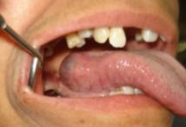

Figure 1 shows swelling over the right posterior lateral aspect of tongue
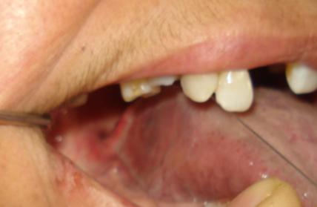

Figure 2 shows blanching of swelling on application of pressure, suggestive of positive diascopy.

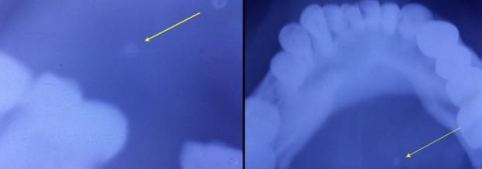
Figure 3 shows soft tissue radiographs of the swelling, arrow suggest presence of phlebolith within the swelling

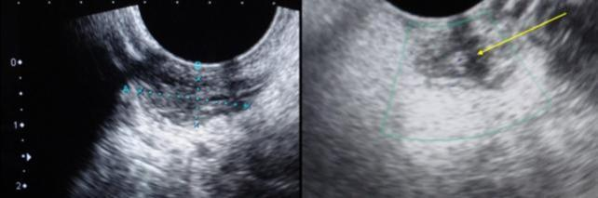
Figure 4 shows USG of the swelling suggestive of a mixed hypoechoic&hyperechoic lesion of size around 17x 17mm with presence of phlebolith (arrow).

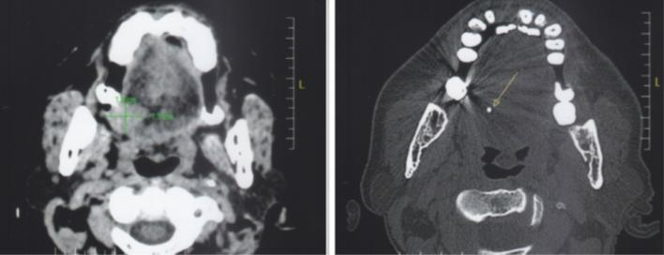
Figure 5 shows non contrast CT scan suggestive of 19 x 15mm size mixed hypodense&hyperdense lesion over right posterior lateral aspect of tongue with presence of phlebolith (arrow).

